Correlative Conjunctions

🔹 What Are Correlative Conjunctions?
# Source: AI Source: Provided by: [Data Path: Persons Table -> ID Column: 1, Name_En Column: Motasem Essam] -> From: [Chatgpt (GPT-4-turbo)] on [7/28/2025]
Correlative conjunctions are pairs of words that work together to join equal elements in a sentence (such as words, phrases, or clauses).
They help express relationships like choice, contrast, comparison, or addition, and they always appear in matching pairs.

✅ Common Correlative Conjunction Pairs
# Source: AI Source: Provided by: [Data Path: Persons Table -> ID Column: 1, Name_En Column: Motasem Essam] -> From: [Chatgpt (GPT-4-turbo)] on [7/28/2025]
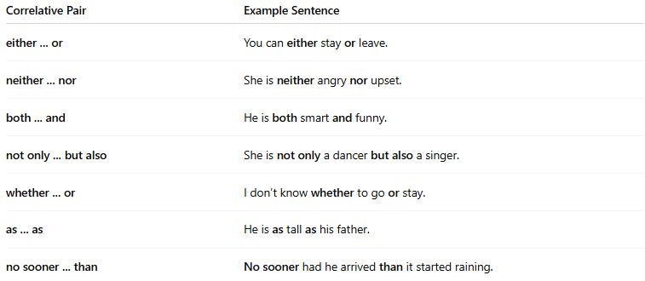
Correlative Pair | Example Sentence
either ... or | You can either stay or leave.
neither ... nor | She is neither angry nor upset.
both ... and | He is both smart and funny.
not only ... but also | She is not only a dancer but also a singer.
whether ... or | I don’t know whether to go or stay.
as ... as | He is as tall as his father.
no sooner ... than | No sooner had he arrived than it started raining.

📚 Example Sentences
# Source: AI Source: Provided by: [Data Path: Persons Table -> ID Column: 1, Name_En Column: Motasem Essam] -> From: [Chatgpt (GPT-4-turbo)] on [7/28/2025]
- Both my mom and my dad are teachers.
- Neither the dog nor the cat likes the rain.
- She is not only smart but also creative.
- Whether we win or lose, we must try our best.

🧠 Key Rules
# Source: AI Source: Provided by: [Data Path: Persons Table -> ID Column: 1, Name_En Column: Motasem Essam] -> From: [Chatgpt (GPT-4-turbo)] on [7/28/2025]
- The parts joined by correlative conjunctions should be grammatically parallel:
  - ✅ She likes both singing and dancing.
  - ❌ She likes both singing and to dance.

